Human Rights and Diversity Committee Statement in Solidarity with LGBTQX Youth and Young Adults, Teachers, Faculty, and Allies

The Human Rights and Diversity Committee of the Division on Career Development and Transition (DCDT-HRDC) wholeheartedly supports the inclusion of Lesbian, Gay, Bisexual, Transgender, and Queer (LGBTQX) students in k-12 and higher education. As a committee and representatives of DCDT, we find the recent policies and legislations targeting educators, students, and service providers alarming. There are approximately 120 anti-LGBTQI+ bills active in the US (https://www.aclu.org/legislation-affecting-lgbtq-rights-across-country) that propose to limit LGBTQ equality and curriculum restrictions. If you are unfamiliar with recent policy changes targeting transgender youth, please review UCLA’s Williams Institute Report https://williamsinstitute.law.ucla.edu/publications/bans-trans-youth-health-care/. In brief, it is currently estimated that nearly 60,000 transgender youth are at risk of being denied gender affirming care (i.e., losing access to a ranges of care including surgery to speech therapy, that support a transgender or nonbinary person in their gender transition). The map below estimates how many youth in which state could possibly lose affirming health care.
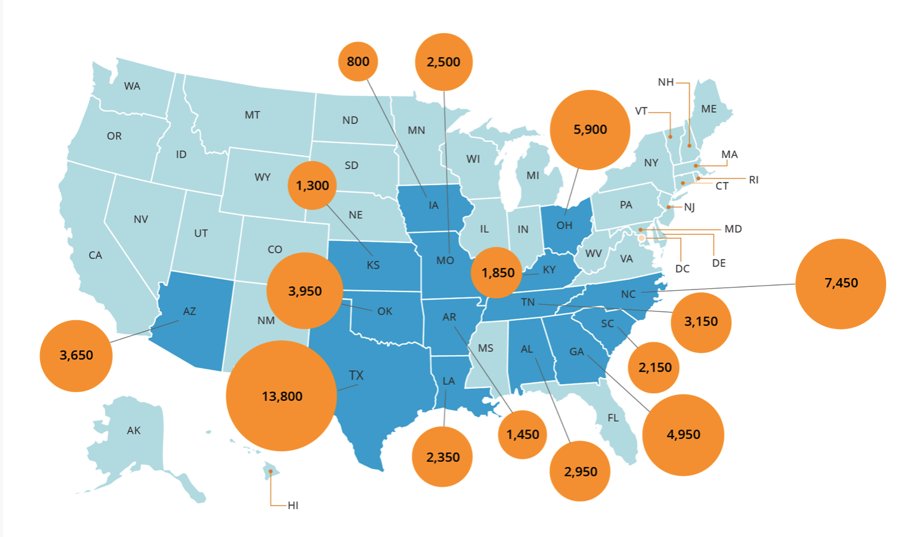

We stand behind the strong, lively, and loving communities of individuals who are LGBTQX. We stand behind the unique experiences, their individual contributions, and lenses in which they view their world. We stand behind brave LGBTQX students who walk through school buildings and enter educational environments that have been designed and are being designed to oppress expression of identity.

We extend our support to teachers who provide spaces for LGBTQX youth to feel at home, to feel seen, and to feel safe. We extend an open invitation to teachers who support LGBTQX youth as they plan for their future to contact us to engage in further conversation and resource sharing. We encourage teachers to see all identities as a strength, to see all communities as an asset, and to see each individual student as a human that matters.

In addition, DCDT’s HRDC members are unconditionally supportive of LGBTQX students. As a youth that will impact our world we want you to know that you matter, you will thrive, and we look forward to seeing you accomplish so many things.

As the DCDT-HRDC moves forward to support LGBTQX individuals in education, we will continue and expand our actions supporting the LGBTQX community.

- First, we will continue to ensure representation of LGBTQX identities in HRDC materials and presentations (e.g., DCDT HRDC Townhalls and DCDT Conference Presentations).

- Second, as we develop a process for sharing information with teachers and other transition practitioners, we will ensure there is a specific topic with resources that will support LGBTQX students.

  - Substance Abuse and Mental Health Services Administration (SAMHSA) - Blog
  - Substance Abuse and Mental Health Services Administration (SAMHSA) - Website
  - GLSEN – Gay, Lesbian, and Straight Education Network – Response to “Don’t Say Gay” Bill
  - GLSEN – Gay, Lesbian, and Straight Education Network - Website
  - The Trevor Project - Website
  - VR Technical Assistance Center for Quality Employment (VRTAC-QE) - https://tacqe.com/lgbtq-and-disability-training-series/

- Third, we will look toward ways of having more members of the LGBTQX community (youth, professionals, practitioners) involved in decision making and review of materials disseminated by the HRDC.

- Lastly, HRDC is always open for feedback that can help us grow, be more inclusive, and responsive, so please do not hesitate to connect with our committee at any time to begin a conversation.

