
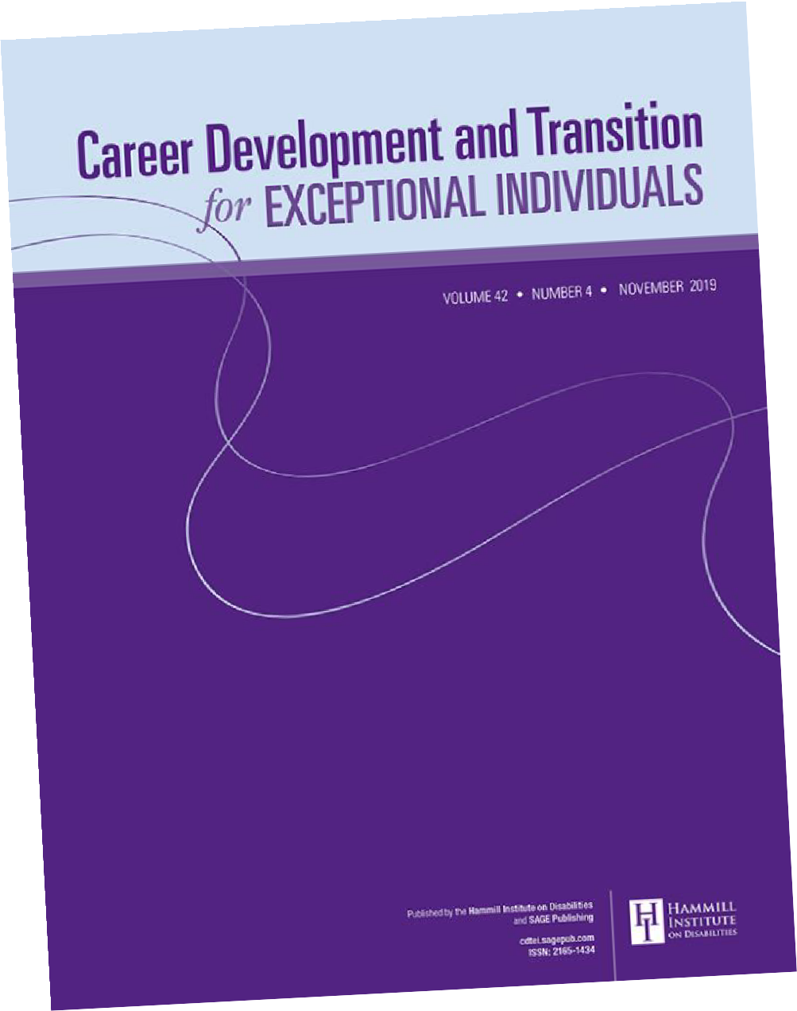

Call for Papers
Career Development
and Transition for
Exceptional Individuals
Co-Editors:
Allison R. Lombardi
University of
Wisconsin-Madison, USA

Valerie L. Mazzotti
University of Kansas, USA

journals.sagepub.com/home/cde

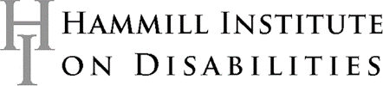
Career Development and Transition for Exceptional Individuals specializes in the fields of secondary education, transition, and career development for persons with documented disabilities and special needs. CDTEI focuses on the life roles of individuals as students, workers, consumers, family members, and citizens.  The journal welcomes submissions that reflect original quantitative, qualitative, or mixed-method research; scholarly reviews; and conceptual or discussion papers.  For descriptions of research studies, (a) the research or evaluation method must be connected closely to the question(s) being addressed and (b) the setting, participants, and procedures should be described in sufficient detail to allow for possible replication.  Submit your manuscripts online at  mc.manuscriptcentral.com/cdtei  Author Guidelines are available via the Instructions & Forms link on the site | All manuscripts should include compelling recommendations for secondary education and transition practice that could be applied at the system, program, or individual level.  Accepted articles may be eligible to earn badges recognizing open scientific practices, including publicly available data, material, or preregistered research plans. You can read more about the open science badges in our author guidelines.  This journal is a member of the Committee on Publication Ethics (COPE).

